World Day of Prayer

Prepared by the WDP Committee of Vanuatu

March 5, 2021
“Build on a Strong Foundation”
Children’s Program
Preparation for the facilitators
It would be helpful for the children’s program facilitators to revise the Country Background Information, Bible Study and Worship Service written by WDP Vanuatu. These resources would provide more information about the country and Biblical content to develop the theme for children and youth activities. If available prepare the PowerPoint to share pictures from Vanuatu.
The facilitators may divide up the introductory information about the country to be read by the older children while pictures are showed.
Have a world map in the room. Give the children time to locate Vanuatu on the map, and trace a line with their fingers or threads to their own country.
Bring some pictures or fresh root vegetables and fruits that may be cultivated in Vanuatu. If possible, serve the fruits or vegetables to the children.
Practice the song “Children Arise and Build.” When singing for the second time, replace the word Vanuatu for the name of your own country.
The Bible Story of the program is Matthew 7:24-27. It is a story that is very easy to engage children in role play, games or other creative activities. Prepare this moment ahead of time. Reproduce the illustrations provided to tell the story. Choose some games according to the age level of the children in your group to help them connect the Bible story with their context.
Motivate the children to talk about everyday decisions that can make them wiser as they relate to their family, friends, neighbors, themselves and God. You can use examples as simple as choosing to eat fruit rather than candy, listening to their parents, taking the initiative to make friends, throwing trash in the garbage bin, reading the Bible, enjoy studying, being kind to others, etc.
Remember that the focus of the Bible story in Matthew is not the construction of the house; this is a metaphor to explain that the ones who act on Jesus’ words are like a wise builder. Jesus speaks about making choices to live wisely, and children can relate to that in many ways.

Children’s Program
Welcoming
We welcome each of you to the World Day of Prayer celebration! Today, we will learn about the children of Vanuatu and their life in the villages and islands of the Pacific Ocean.
Let’s find on the world map where Vanuatu is located. (Give time for the children to locate Vanuatu on the map, and trace a line with their fingers or threads to their own country.)
Learning with Vanuatu children
The country - Vanuatu is an independent country located in the South Pacific Ocean. It has many islands and beautiful beaches. The islands are prone to natural disasters such as cyclones, floods and volcanic eruptions. The severest Category 5 Tropical Cyclone Pam hit Vanuatu on March 13, 2015.
The climate - Vanuatu has only two seasons: the hot and humid season from November to March, when there are heavy rains and winds like cyclones; and the dry season from April to October when the climate is temperate.
The animals - There are no indigenous large mammals, poisonous snakes, or spiders. Wild pig and fowl are indigenous. The wild pig is very important to Vanuatu culture, with the tusks included as a national symbol on the coat of arms. The region is rich in sea life, with turtles and dolphins, and many species of fish.
The food - Most of the fruits and vegetables are organically cultivated, except the ones that are imported. The beef is considered one of the best in the world.
The school - Most children live in rural areas with no schools. Some have to walk long distances to attend school or leave their villages for boarding school.
The people - The indigenous people are mostly Melanesians and a small number of Polynesians. There are also people from other Pacific Islands living in Vanuatu, as well as from Asia, and countries like England, France, or the USA.
The languages – They speak many languages in Vanuatu, each child may speak their local language at home, and learn Bislama, English or French in school.
Vanuatu children are known for their naturally beautiful smiles. How about sharing our own smiles with each other? Let’s smile! (Create circle with the children and give them time to have fun smiling to each other kindly. End this moment with the following prayer)
Prayer - Sweet Jesus, we thank you for loving us as the children of the world. We are together worshiping you and listening to your word. Thanks for the beautiful smile of the children of Vanuatu. In the sweet name of Jesus, we pray. Amen
Song - Composed at the WDP Preparatory Workshop by members of the WDP National Vanuatu Committee for the 2021 program. ©WDPIC. Used with permission
Repeat the song replacing the word Vanuatu for your country)
Children arise and build
On the strong foundation now (x3)
Jesus, the strong foundation
Vanuatu arises and builds
On the strong foundation now (x3)
Jesus, the strong foundation
Listening to Jesus’ teaching – Matthew 7:24-27
(Before starting the Bible story, organize with the children a role play. Ask for volunteers to be the builders, the houses and wind-noise makers. Tell the story with your own words or read the Bible text while the children make the gestures described in the story. Remember to include Jesus’ advice – “Everyone then who hears these words of mine and acts on them will be like…” (24, 26). That is the difference between the wise and the foolish. The building of the house is an illustration for this alert. Then conclude the story motivating the children to respond to the questions.)
Introducing the Bible story
Jesus has an important message to tell children. He goes to a hill outside the village and teaches people about God. His message to us is that every child is part of God’s family. Jesus teaches children to live wisely. Let’s hear what Jesus taught.
One day, Jesus went up to a mountain and many men, women and children followed him to hear his teachings. Jesus preached a long sermon on the mount (Matthew 5-7). He had a lot to say to help people live well in their communities and families. He said, for example, that the ones who are sad, God will comfort (Matthew 5:4). And, the golden rule - do for other people the same things you want them to do for you (Matthew 7:12). Jesus’ teaching is a strong foundation for children to grow up with.
Jesus was about to conclude his teaching, when he said “everyone who hears my teaching and follow it will be like a wise person. Everyone who hears my teaching and forgets to follow it will be like a foolish person.” Then, he finished his sermon with a story to help people remember what to do when they need orientation. What is the most important thing a child can do to have a good day? Be smart! How? (Let children participate with their responses.)
(Narrate or read Matthew 7:24-27 while the children role play).
Sample of conversation topics with children or youth
Two people built two different houses in two different places. One builds the house on the rock, the other on the sand. Both houses were completed and both builders moved into their houses. It was the cyclone season and soon the rain came, the strong wind blew, just like a tropical storm. There was confusion and fear. Then the wind calmed down and the rain stopped. What happened to the two builders and their houses?
Those two houses are for us to remember Jesus’ teaching. Which house looks like the one built on Jesus’ teaching?
In this story, Jesus displays two contrasting houses like they are two types of actions a person may take after Jesus’ teaching:
- A wise person trusts and obeys Jesus especially when it is hard
- A foolish person forgets Jesus’s teaching when it is most needed
When we trust Jesus and do his will we know that we have a place with God forever. He promised to be with us no matter what happens to us in life. God is the source of everything we need, and he has a plan for each of our lives.
We are wise when we listen to Jesus and then do the things he tells us. When we put our trust in Jesus we become a member of God’s family and builders of God’s Kingdom. We are forever God’s children.
Sample of questions for conversation based on the illustrations page 9
- What do you see in the pictures?
- If your parents or friends gave warnings to you, what would some of these warnings be?
- What does it look like to be a child (or youth) who remembers Jesus’ teaching?
- What have you learned from this story?
Conclusion
Jesus said that people who ‘hear and obey’ his teaching are wise. Jesus is telling us that if we build our lives on him and obey his word, we will grow up to be wise like the wise builder. We shall have not only safe shelter in our houses but also find shelter in God’s love. This is the strong foundation of our lives. This is like a spiritual house that cannot be seen with physical eyes, but it is seen through our actions towards our family, friends, or neighbours.
Song: Be Good Listeners to God’s Word. Composed at the WDP Preparatory Workshop by members of the WDP National Vanuatu Committee for the 2021 program. ©WDPIC. Used with permission
Be good listeners to God’s Word
Be obedient to His ways
Put God first in all you do
Build wisely for eternity.
Closing Prayer - Our Father in Heaven, we thank you for your word. We want to learn how to walk and live in your way. Help us to hear and obey your word. We want to have Jesus as the foundation in our lives. Help us to live according to Jesus teaching, so we can spread the love of God in our community. Amen
Activities for older children or youth (senior and junior)
- Puzzle – Copy the Bible text, and cut the phrases of the story. Cut out the verse number. Use the phrases to create the puzzle. Ask the children to put the story in the sequence they think corresponds to what Jesus taught. Let them share the sequence they created and lead the conversation to new insights the exercise helped them to understand the Bible story.
- True and false - (Put your hand up, if I say something that is true. The correct answer is between parentheses)
- God sent Jesus to teach people about building houses and sheds. (False)
- Jesus said, “Hate your enemies and hate your neighbours.” (False. Love your enemies and pray for those who mistreat you.)
- Jesus said that people who ‘hear and obey’ his teachings are wise. (True)
- The house that was built on the sand was strong. (False)
- The house that was built on the rock was strong. (True)
- On the strips of paper write verses of the story, bury in sand, then let the children find it and read, while the small children create gestures to express the story from Matthew 7:24-27.
- Complete the definition of what it is to be wise (page 5).
- Arts & crafts ideas: Woven paper basket, table placemat or ball (pages 5-7).
- Join the dots to find the building on the rock (page 8).
- Bible story illustrations (page 9).
d. Complete the definition of what it is to be wise
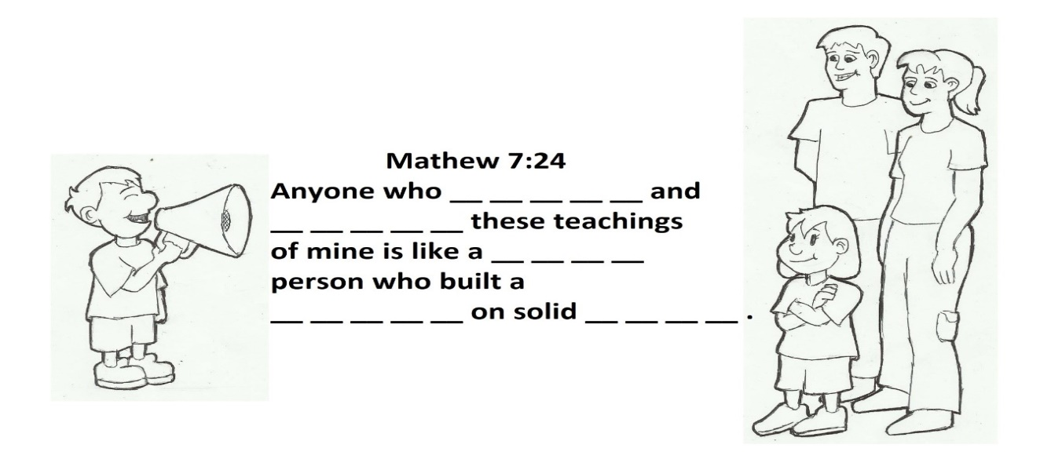
e. Arts & crafts ideas: Woven paper basket, table placemat or ball
Let the children decorate the table for World Day of Prayer with colorful woven placemats in the colors of the Vanuatu flag. The Vanuatu flag is red, green, black and yellow. You may use any combination of card paper, fabric, straw or recycled material like newspaper for this activity.
Vanuatu children are very resourceful in filling their days with adventure and games. Their favorite game is to make their own balls to kick and throw to each other. Traditionally the balls are made from the leaves of the Pandanus Palm. They like to play soccer with this ball, even though it is smaller than the official soccer ball.
It is important for Vanuatu children to learn how to weave, as they grow older, they use this skill to make baskets, mats and even their homes. This simple project teaches the foundational skills for weaving.
You can find instructions for woven paper basket, table placemat or balls in an arts & crafts magazine in your country or search for instructions or video clips on the internet. Be aware of copyright permission before reproducing instructions on the materials.
For a sample of a website with instructions, visit:
- for paper ball, visit https://www.homemade-gifts-made-easy.com/christmas-ornaments-to-make.html (Copyright permission required to reproduce instructions)
- for paper basket, visit: https://www.wikihow.com/Make-a-Paper-Basket. “How to make a paper basket.” User Content text on wikiHow under a Creative Commons license. Instruction by 19 co-authors, updated on March 29, 2019. (Include copyright information, if reproducing the instructions below)
Simple Construction paper basket
- Prepare strips of paper to weave your basket. Use three sheets of 8.5" x 11" construction paper. On the sheet of paper to become the base of your basket, draw a horizontal line 3.5 inches (8.9 cm) from the top and another one 3.5 inches (8.9 cm) from the bottom. These lines will help when laying out the base. Then cut the paper lengthwise into strips .5" wide.
Choose one sheet of a neutral color of construction paper like brown, black, or white. This will be the base of your basket. The other two sheets can be any color of your choice. This will form the decorative sides of your basket.
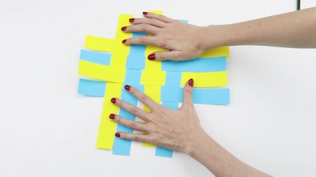
- Weave the base of your basket. Lay out 8 strips of paper (the color you've chosen as the base) next to each other so that the lines on each strip are face up and form one continuous line. Starting at the top line, weave another strip of the same color through the strips you've laid out, over one strip and under the next.
Center the strip horizontally with respect to the strips you laid out. Using another strip of the same color, weave it through the strips in the opposite way from the first one, so that this one will go underneath the strips that the first one you weaved went on top of. Then slide the strips together, making sure the edges line up.
- Repeat with a total of eight strips.
- The finished base should have a 4" x 4" woven square that fits just inside the lines you drew on each strip. In other words, you should have a square that has eight strips sticking evenly out 3.5" on each side.
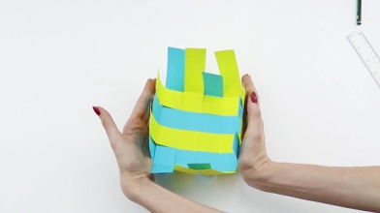
- Fold up the strips sticking out the sides of the basket. Each side should come up to the same height. It can be helpful to put a 4" x 4" box or block of wood in the center of your basket and fold the strips up against this block. This will make the next steps easier.
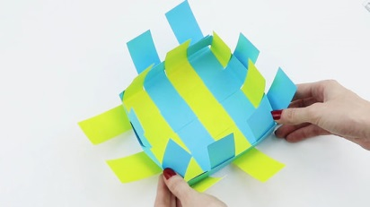
- Weave a strip of colored paper between the now vertical strips of the base, folding it to fit around the corner of the basket.
You will need to use approximately one and a half strips to make it all the way around the basket. You can simply tape or glue the two pieces together. Try to place the connection so that it comes on the inside of the basket and is hidden by a strip from the base. This will give your basket a clean, seamless look.
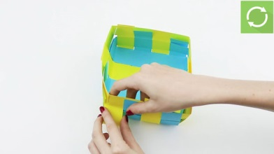
Weave the strip all the way around the basket. When the two ends meet, tape or glue them together, hiding the tape in the same way.
- Repeat the above step with another strip of the same color. Make sure to alternate between going under and on top of strips, so that you create a checkerboard pattern with the strips from the base.
Keep repeating until you reach the top.
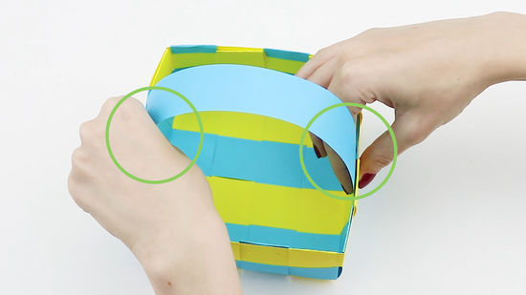
- Finish and polish off your basket. Tape or glue the ends of the base strips to the top woven strip.
Then tape or glue a slightly wider strip of the base color to the top of the basket on the inside, laying it on top of the vertical strips. Add a similar panel on the outside of the basket, securing it to the inside one as well as the outside of the basket.
If you want to add a handle, simply tape or glue each end of a long strip of paper to opposite sides of the basket before you add the top panel.

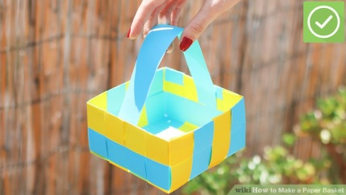
- Done.

This material is part of the worship service and
educational resource for the 2021 WDP annual celebration.
For further information, please, contact:
World Day of Prayer International Committee
475 Riverside Drive Room 729
New York, NY. 10115. USA
admin@worlddayofprayer.net - http://worlddayofprayer.net

f. Join the dots to find the building on the rock 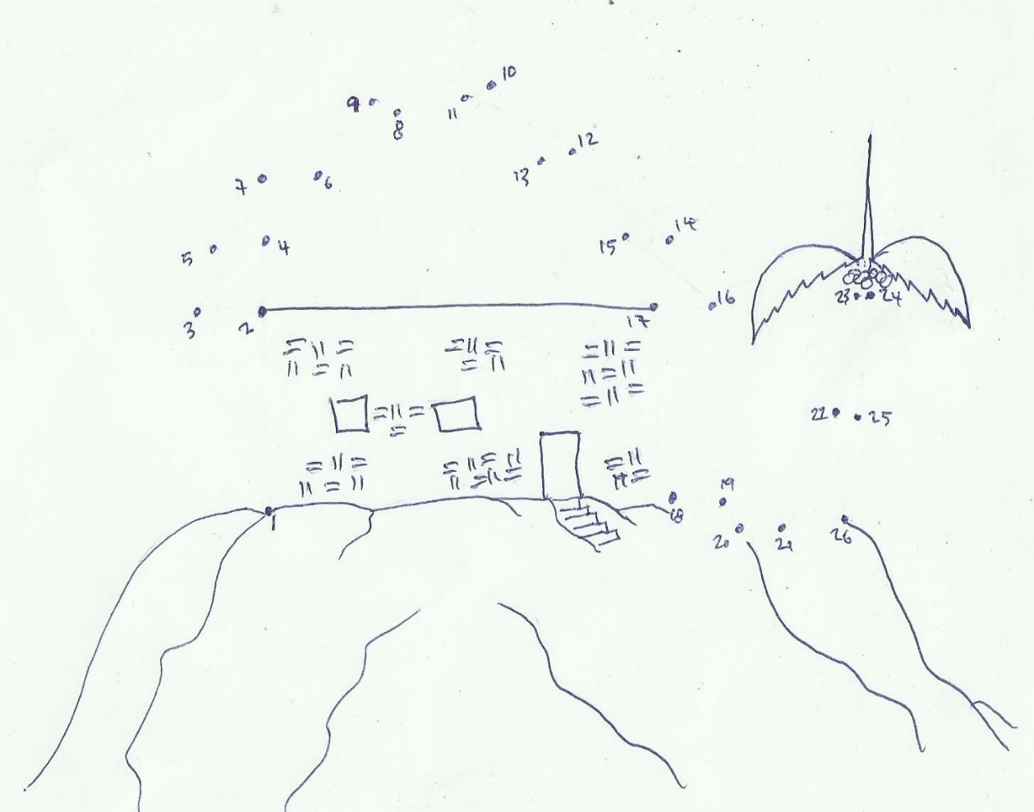

g. Bible story ilustrations
