World Day of Prayer
Prepared by the WDP Committee of England, Wales and Northern Ireland
March 4, 2022
“I Know the Plans I Have for You”
Children’s and Youth Programme
PREPARATION
This programme is designed for children ages 5 to 12, and youths ages 13 to 18. There are several activities for each group, please read the full programme to plan accordingly. Also, please note that some of the activities may require preparation.
It is recommended that the Leaders for the Children’s and Youth Programmes familiarise themselves with the Bible Study and Country Background beforehand.
THEME: “I Know the Plans I Have for You”, based on Jeremiah 29:1-14 (New Century Bible), which for the Children’s and Youth programme carries the message that God is always with them, and God gives us hope at all times:
- when we are happy or sad or in between
- when bad things happen to us
- in times of change, disappointments and loss
- at times of joy and celebration
Children’s Programme for Ages 5 – 12
For the Leader: Talk to the children about how we find out about what has happened during the day. Ask them for suggestions (ex: radio, newspapers, television, friends, school, etc.). Maybe have one or two newspapers to look at.
All these things tell us what happened yesterday or what happened last week. The Bible has stories that happened in the past. Our story today is based on what the prophet Jeremiah told the people of Judah after they had to leave their land. They were sad and the job of the prophet was to keep the hope for the future, a future that is for God to give them.
‘I have good plans for you, not plans to hurt you. I will give you hope and a good future….And I will bring you back from your captivity…. And I will bring you back to this place. (Jeremiah 29:11-14).
We trust that God has plans for all of us and we know that we should hope for a good future.
Encourage the children to talk about what they would hope to do, where they would hope to go, what they think God may have planned for them.
Use the Postcard template for them to draw or write `My hopes are….’.
Song: ‘God has a Plan for Me’ by Martha Bolton and Bob Singleton. CCLI#5623161, ©Agnes Day Music & Sky Taylor Music
or ‘He’s got the Whole World in His Hands’
Leader: There are some times when we have to do things we don’t want to do, or go places that we don’t want to go and say goodbye to friends. These could be times when we are sad and unhappy. This is the story of a young girl who has come to England from a long way away.
Anisa’s story: (Important note: This could be dramatized or mimed as it is read, but this is at the discretion of the leader who should be sensitive to the children’s individual situations.)
Leader: Have you ever been somewhere where you didn’t know many people? What did that feel like? Sometimes people have to leave their homes to go somewhere for safety. They may become refugees like Anisa. This is her story:
Anisa: `My name is Anisa. I am 5 years old and I live in England now, but I came from Iran. My mummy, daddy and me came here in the back of a very large truck. We had to hide behind lots of big crates and be very quiet. We had to leave our country because there were people there who seemed very angry at us and made us feel frightened. Even mummy and daddy were scared and said we would have to leave home and go away. I cried and didn’t want to go, but mummy told me that God would help us and keep us safe’.
Leader: What thing would you miss more than anything else if you had to leave your home?
Anisa: `The journey was so long and we were very tired and uncomfortable. There was another family with us too, and we were often sick. We were hungry and thirsty. I tried not to cry, but I missed my own home and my doll that I loved very much. It was dark and very cold when we climbed out of the truck. We only had the clothes we were wearing. My daddy carried me across a field and along a road. I know that mummy was very frightened and I was too. I don’t remember where we fell asleep the first night here. Everything seems very muddled now.’
Leader: What do you think it would feel like not to have a home or friends? How important is it to have a friend? How can you be a good friend to someone – maybe someone new to your school?
Anisa: `We have lived in different places until we got to this town. Now we have a rented flat and I go to primary school. This is where I met Susan. I was learning English and we could talk. She became my friend. She knew that I was feeling sad and scared. I was always feeling cold and hungry. Susan told her grandma about me. Her grandma went to her church and they contacted another church where many Iranians met together. They came and brought us some more clothes, bedding and some toys for me! My favourite is a baby doll with knitted clothes that Susan’s grandma gave me.’
Leader: So many small things can make a very big difference, can’t they? God will always give you something to hope for and changes will happen.
Anisa: `I am so happy to live here now. My daddy has got a job and my mummy is studying at the local college because she wants to be a nurse. Now I am glad that we came here - even though we still miss our first home and my family there. Now I know that God had a plan for us.’
Leader: We know that there are many people from many different countries who are trying to find a new home, sometimes far away from their own country. They have to travel on long dangerous journeys and say goodbye to their families and friends. They want freedom and safety and God will give them hope for the future.
Prayer Ideas:
Use one or more of these ideas to share the children’s prayers:
- PRAISE: Use a sheet or length of fabric as a `parachute’. All the children hold an edge of the fabric and raise it together saying:
We lift our thanks to you! We thank you for…..and go round each child as they say something they are thankful for, as they lift the `parachute’ each time.
- With the children sitting around in a circle, pass a stone around. As each child holds the stone they are asked to think of something they may need to say SORRY for and ask God to forgive them.
- HOPSCOTCH PRAYERS: Draw out a grid with numbers 1 – 6 on the ground. Use a pebble or stone to throw into each number in turn. When it lands, the child must hop to each number in turn and on the number with the pebble pray for the corresponding topic:
- Thanks: Say thank you to God for one thing today.
- Sorry/Forgiveness: Is there something the child needs to say sorry to God for and ask for forgiveness? For wrong words, actions or even attitude?
- Please: Think of the people of England, Wales and Northern Ireland and ask God to bless them, especially the children and the young people there today.
- Thanks: Think of two more things to be thankful for….
- Please: A prayer for their own family and friends today.
- Hope: Think of something they would hope for in the future.
Conclude with: Dear God, we thank you for keeping Anisa safe and giving her and her family a happy future. We pray for all the many children who have had to leave their homes and travel to new places to feel safe. Watch over them when they are sad or frightened and give them hope. We are sorry for the times when we have done things we know are wrong, the times when we have upset others by saying or doing things that are unkind. Thank you that, like a loving father and mother, you forgive us and help us to forgive others. Thank you that you give us hope for the future. Amen.
Craft Activities:
- Colour the flags of England, Wales and Northern Ireland.
- Paint or decorate a stone. If the stone is large enough, then a message can be written, such as HOPE, LOVE, JOY or PEACE.
- Draw or use the large heart shape on card or paper, with a smaller heart shape in the centre. Decorate around it by gluing things on, painting/colouring patterns or thumb-printing. In the centre heart write your message, as above or GOD LOVES YOU.
- For the older children: Use the template and instructions to make a woven paper heart bag. (A few sweets could be put inside.)
The children might choose to give their decorated items to someone as a sign of God’s love to them. God needs us to pass the messages on, as the prophets did.
Games:
Trust games: Sometimes it is hard to put our trust in God! We have to let go of our own fear and let God lead us. Have a go at any of these games:
- Catch me! One person leans backwards, letting themselves fall, trusting that their friend will catch them. Try not to take a step backwards! (For safety, an adult should be close at hand to respond if necessary.)
- Obstacle course: Set up a simple obstacle course using whatever you have on hand. It can be around, under and over furniture, people, play equipment or natural obstacles outside. In pairs, one person is blindfolded and the other has to call out directions to guide their partner around the course. Then switch over so that they each have a turn at guiding or listening and following instructions.
- Lap sitting: All stand in a circle facing the same direction to the left or right, close together. At the count of three, all sit down on the lap of the person behind. Keep your hands free! This is possible with large groups of people, but the secret is in sitting slowly and gently together. Don’t panic! It is also important to be in a perfect circle to begin.
- With all sitting in a circle, go round the circle fast, speaking the name of one person they want to thank God for, who has been a great support or help to them.
Finding out about England, Wales and Northern Ireland Game: Use the template to cut out and make the spinner and coloured counters, then use the spinner to move around and explore our countries! There are so many facts for you to find out as you travel! Read out the facts that match the numbers!
Interesting facts of England, Wales and Northern Ireland (to accompany the Game)
England, Wales and Northern Ireland are all parts of the British Isles. When Scotland and more than 6,000 islands around us are added as well, we become: `The United Kingdom of Great Britain and Northern Ireland’.
- We each have our own flag and patron saint: St George for England, St David for Wales and St Patrick for Ireland.
Government and Royalty
- We are ruled by a democratic government with an elected Prime Minister, but we also have a Queen (or King) who is our Head of State.
- Welcome to London! This is the capital city and it is where the government buildings are. These are called the Houses of Parliament. There is a clock tower there with a famous bell called Big Ben.
- The official London home of the Queen (or King) is called Buckingham Palace.
- We have many historic houses and castles. The oldest royal home is Windsor Castle. It was built more than 900 years ago and is the largest royal home in the world and still being lived in!
- Do you know that when people reach their 100th birthday they get a card from the Queen (or King)?
Things to be Proud Of
- We may be a small island - but we have a long history of inventors who have brought new knowledge to the world.
- Our educational system: all children get a free education until they are 18. We also have fee-paying private or independent schools. We get many students coming from other countries to go to our universities. Oxford and Cambridge are England’s most famous and historic universities.
- How lucky we are to have such a temperate climate – no extremes in any way! We are proud of our lush green countryside and farm land.
- Because we are all islands, nowhere in the country are we more than 75 miles from the sea!
Over the Irish Sea
- Now we travel across to Northern Ireland - the main city here is Belfast and the Irish folk are here to welcome you! They are famous for their hospitality.
- The Giant’s Causeway is a very famous rocky area of the coast in Northern Ireland. It looks like thousands of giant steps. It is made up of thousands of hexagonal blocks of rock, formed by ancient volcanic eruptions.
- Loch Neagh, in Northern Ireland, is the largest lake in the British Isles.
Back Across the Sea
- To Wales – another beautiful part of our islands! All the road signs in Wales are written in two languages: Welsh and English.
- One town in Wales has one of the longest names in the world:
Llanfairpwillgwyngyllgogerychwryndrobwllllantysiliogogogoch
(which means: Saint Mary’s Church in the hollow of the white hazel near a rapid whirlpool and the Church of Saint Tysilio of the red cave.)
- From all parts of our countries we have many famous authors, poets, explorers and composers who are known all around the world.
More things to know
- Football (or soccer) originated in England, and other sports such as cricket, rugby and tennis all started here. Some of our football clubs are known all over the world.
- If you go anywhere in England, Wales or Northern Ireland you will be sure to try some favourite foods like: fish and chips, varieties of sandwiches, cheeses and cream teas!
- There are beautiful beaches and coastlines all around us. Fishing and sailing, surfing and swimming – but be careful, the seas that surround us can be very cold!
- Stonehenge is a famous prehistoric monument made up of a ring of massive standing stones. It is older than the Pyramids of Egypt and thought to have been created about 3,000 BC.
- Believe it or not, the postage stamp originated here! The first stamp was issued in 1840.
- Our currency of pennies and pounds is one of the oldest in the world that is still in use after 1200 years.
- So – back to London again! London has the largest library in the world.
- London also has one of the oldest transport systems in the world and one of the largest – both under-ground and above-ground.
- London is a city where many people from countries all around the world come to visit. It has the highest number of languages spoken, by inhabitants and visitors, than in any other country – more than 300 languages.
Finish! We hope you have enjoyed your trip around England, Wales and Northern Ireland!

Resources for the activities:
- Country Flags to colour
- Postcard ‘My Hope Is….’
- How to make a Woven Heart Basket
- Explore our Nations Map Game

Country Flags to Colour

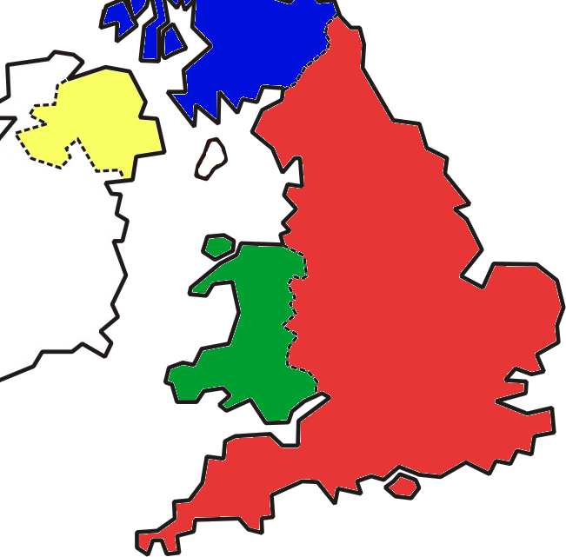

START
Set sail for England!
3
26
25
24
23
12
9
8
7
6
5
Wales
4
2
1
Finish!
Scotland
Ireland
Northern Ireland

14
13

11
10
England

15

1
16

1

17
6
2
2

5
3
22
4
21
18
20
Welcome, explorers! Your mission: To explore England, Wales and Northern Ireland, all parts of the United Kingdom of Great Britain and Northern Ireland. Find out more about us and our three nations. You will need dice, or make the spinner, and each player will need a counter. Take turns to roll the dice or spin the spinner and then move your counter. Be prepared for an adventure! If you land on a circle with a number you must read the corresponding fact on the sheet to the group.
19

Cut out the spinner (above) and put a thin straight stick through the centre to spin.

1
2
3
4
5
6
Counters

Youth Programme for Ages 13 – 18
Leader’s notes: These activities have been laid out in a cohesive manner for a reflective youth session. Through the various activities, the theme is: “I Know the Plans I Have for You”, based on Jeremiah 29:1-14 (New Century Bible), which emphasizes that God is with them through the good and the bad with a hope-filled purpose and vision for their life.
Pastoral guidelines for leaders: In order to create a safe space for sharing, please follow these guidelines.
1) Everything shared in this group should be kept confidential - the exception to this is if a person is at risk of harming themselves or others.
2) Seek to accept and not judge what is said - a safe space respects everyone.
3) Work within your own safeguarding and good practice guidelines.
4) Take care of yourself too - if something is difficult, please make sure that you have someone to talk to.
Introductory game – True or False? (10 minutes)
Aim: To introduce some of our cultural objects from England, Wales & Northern Ireland.
You will need: Copies of the photos.
Show the photos to the young people and share the two explanations. Ask them to identify the correct answer by voting. To make it even more fun, get two leaders to read an explanation each and try to convince the young people that their version is correct. The correct answer is in bold.

A: This is a wooden spoon decorated with symbols of love and made by a man presented as a gift to his sweetheart. The tradition dates back to the 1600s in Wales and was intended to show the skill of the carver.
B: This is a small raft designed in the shape of a spoon. The aim was to sail the raft across a puddle in Wales to your true love without it sinking to show your boating abilities.

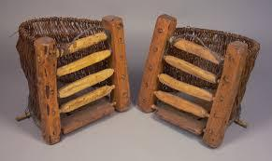
A: This is a bardog - an early wooden instrument for children in Northern Ireland. A child would sit in it and use a wooden spoon to create music on the ridges.
B: This is a bardog (a large basket) which was hung off the side of a donkey or small pony, used for carrying turf, or more usually manure such as animal dung, for spreading on land as fertiliser in Northern Ireland.
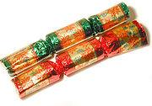
A: This is an object which holds a small gift or toy inside and is usually pulled apart by two people at Christmas across the UK.
B: This is a material used by people in England to make fire at Christmas.
Explain: Every object has a purpose. Can you think about some objects that are special where you live and which may tell others something about the way people live in your country?
Everything has a purpose and that includes you. What is God’s purpose for my life? (20 minutes)
Aim: To help young people think about why God created them in a simple and creative way.
You will need: A print out of Resource Sheet A, the template of a gingerbread person, and pens.
God made each of us with a special purpose. But I wonder - do you understand why God created you? I know that this sounds like a big scary question – but God created you with skills, passions, and a unique way of looking at the world. This can help you understand God’s vision for your life. Let me explain more:
- EYES – Draw a pair of eyes on your person and write the question - what are the needs that I see around me?
- The world around us is broken and unjust; it is not how God intended it to be. What is the injustice that you see that needs to be transformed? Homelessness? Poverty? Gender violence? Conflict?
- God gives us different spiritual eyes to see different injustices and invites us to be part of God’s mission of restoration.
- HEART – Draw a heart on your person and write the question – what do I love doing?
- God created us with passion in our hearts. What are the things that you love doing? The things that give you joy? For example; running, music, or serving others.
- What sets your heart on fire?
- HANDS AND FEET – On the hands and feet, write the question – what are the skills and talents that God has given me?
- We may live in a world or culture that makes us feel ashamed or modest about our abilities – but God created you with gifts and talents. For example; you may be good at writing, playing an instrument, public speaking, organising, or even making people smile and feel comfortable.
- What are the skills and talents that God has given you? How can they benefit other people?
The activity above is a simple and creative way to think about your God-given purpose. Although you may doubt it, each of us has a specific purpose, a calling that only we are qualified to fulfil.
Overcoming obstacles game (20 minutes)
Aim: To introduce the concept of obstacles in a fun way and help stimulate conversations about how God helps us overcome obstacles to our own hopes and plans.
You will need: A packet of A4 paper and a box of paper clips per team, a photo of The Shard, a small prize for the winning team.
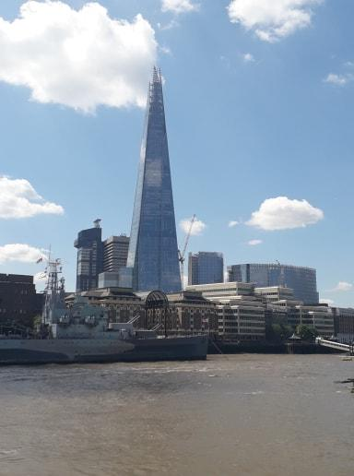
Divide the group into teams no bigger than 4 people. Explain that you have a very special challenge for them. Show a photo of The Shard building, a 95-story supertall skyscraper in London. Explain that standing 309.7 metres (1,016 ft) high, the Shard is the tallest building in the United Kingdom, the fifth-tallest building in Europe, and the 96th-tallest building in the world. Your team challenge tonight is to make your own version of The Shard – but it isn’t going to be easy.
Here are the rules:
- You can only use the materials that are given to you – sheets of paper and paper clips.
- Your tower must be free standing (i.e. not held up against a wall).
- You will have 5 mins to talk to your team members and plan your strategy (but you must stand in a circle facing outwards so you can’t see their faces).
- You will have 10 mins to build your tower but once you start building it, you cannot communicate verbally with your other team members.
After the activity and announcing the winner, have some time of discussion:
- What are some of the obstacles that you faced in this task? How did you work together to overcome them?
- God has a purpose and a plan for our lives but what kind of obstacles do we often encounter to fulfilling it?
- What kind of things can we do when times get tough? How can we experience God in suffering?
Reflection (15 minutes)
Leader’s notes: Please share this reflection on Jeremiah 29:1-14 with the youth group. After sharing, use the question dice in Resource Sheet B to prompt the group to discuss some key questions.
I know the plans I have for you. I have it all planned out – plans to take care of you, not abandon you, plans to give you the future you hope for (The Message Jeremiah 29:11).
This verse shows us how much we are loved and accepted by God. It tells us that God is with us no matter what is happening in our lives. That we are not alone, even if we feel like we are.
It sort of feels like we don’t need to do anything for all this to happen - that God has got it all sorted and whatever it is that you have is all part of God’s plan for you.
How does that feel if you are unhappy though? Does it mean that it’s God’s will for us to suffer sometimes?
I don’t think it does, because the very last part of the verse asks us to get involved with telling God about our hopes - ‘Plans to give you the future you hope for’.
Your hopes matter a great deal to God.
What is really special about this is that God created you to be you. You are the only you on the entire planet. God is interested in your hopes and dreams - whatever is happening in your life.
We do this through talking to God about our lives, our hopes and dreams, our sadness and disappointments. It is sometimes harder to reach out to God when we are suffering because God can feel far away. We are assured in this verse that God does want to hear how you feel, even when you are not feeling good about the situations going on around you.
God wants to participate in your life; in your hopes, your suffering, your joy, your sadness.
God wants to know everything. We just need to remember to tell God.
What’s your #WDPhope? (10 mins)
Aim: Expanding the reflection about God’s purpose for oneself to God’s purpose in the community. This activity encourages young people to think of the injustices in the world around them and commit to transforming them.
You will need: Pieces of paper, markers, phone/camera with access to the internet.
Explain: The world around us is broken and full of hopelessness; this is not how God created the world to be. God created you with passions and gifts to make a real difference. Young people across England, Wales and Northern Ireland are hope-bringers and culture transformers. God is using them to shine light in hopeless places. Just like Grace, from Essex in England. [Share Grace’s photo and story].
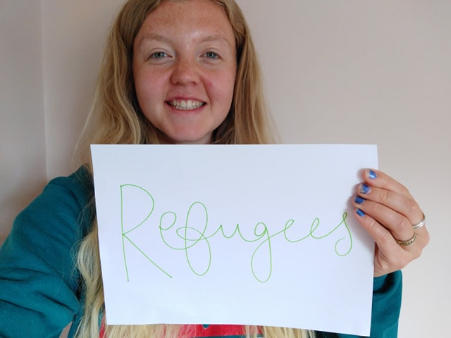
‘My name is Grace and I’m 24. My hope is...that all those who seek safety in the UK are welcomed, embraced, and given the support they need. When the news in the UK began to fill with stories of people crossing the Mediterranean in dinghies and risking their lives to reach Europe, I couldn’t ignore it. My heart broke that people had been forced to flee their homes and were risking their lives to reach our continent. My sadness turned to anger when I saw how European countries, including the UK, reacted to it.
The political hostility and physical oppression made me feel sick. I couldn’t understand how we could deny safety to those who so desperately needed it. My God is a God of justice and this was a serious and harmful injustice that was happening on my doorstep. In September 2017, I moved to Calais to volunteer with the Refugee Community Kitchen. I ended up staying for 6 months, working as a driver and distribution lead. I learnt so much about humanity during my time in Calais, seeing the very best and the very, very worst of it. Some of our days and weeks in Calais were quite traumatic. We got caught up in teargas, in fights, we witnessed the police beating people and pulling them out of the back of trucks, our friends would tell us stories of their experiences in Libya, in the Sahara Desert, on boats across the Mediterranean, in prison, and often they were quite harrowing. I couldn’t bear to think of my friends going through such awful things. God gave me an amazing support network – both in Calais and from home. I think people found hope in friendship. Sure, providing two hot meals a day was vital, but it was by building relationships, checking in on people and treating people as individuals, that we were able to remind people that this was only temporary, that people cared about them and wanted to know their story. That soon, hopefully, they would be safe.’
Grace’s #WDPhope is for refugees. What’s your WDP hope? We want to create a movement of passionate hope-bringers across the world. Share an issue that you’re passionate about by writing it on a piece of paper, sharing it with the group, and then uploading it on social media using #WDPhope.
Grace was passionate about restoring worth to refugees and her passion led her to serve in a practical way. What steps can you take this week which will help transform an injustice?
Closing Prayer (5 minutes)
God of our whole lives,
We thank you that you are there with us when we are suffering, just as much as you are when we feel joy. Even though at times we may feel alone, we know that you are always with us, waiting to be invited into our lives. Waiting to be with us, no matter what.
When we feel alone, scared and hopeless, we ask you to come closer to us. We know that Jesus suffered too, and what seemed to be the end for his hopes and dreams on the cross, it was just the beginning of his resurrection.
Give us voices to share our hopes with others. Give us words to share when we suffer.
We thank you that we can bring both of these to you and to just be ourselves.
Amen.
_________________________________________________________
Copyright © 2020 World Day of Prayer International Committee, Inc.
“I Know the Plans I Have for You” was prepared by the World Day of Prayer Committee of England, Wales and Northern Ireland for the worship service and educational activities for the 2022 World Day of Prayer (WDP) annual celebration. WDP materials are developed for the exclusive use of WDP programs organized by national or local committees and their partner organizations. For any other use, materials from the WDP 2022 Resource Packet may not be reproduced without the permission of World Day of Prayer International Committee (WDPIC).
Limited reproduction rights granted—Bible study, Worship Service, Country Background, Children’s Program, Artwork and Artist Statement, WDP composed songs and photos may be reproduced—printed or electronically—for WDP activities with congregations and groups, if appropriate credit is given. WDP National/Regional Committees are permitted to resell reproductions of the resources for the purposes of the WDP program.
Only WDP National/Regional Committees connected with WDPIC can make the resource packet or sections of the materials available online. Committees that make materials available online must ensure groups and individuals who access the online materials are accountable to the committee.
The songs suggested for the worship service and children’s program include copyrighted information from the publishers. Permission to reproduce or translate the songs must be obtained from the publishers. WDPIC only gives permission to reproduce or translate the songs that are originally composed for WDP programs.
Any offerings or funds collected related to WDP activities must be reported to WDP committees.
Scripture quotations are from the New Revised Standard Version of the Bible, copyright © 1989 by the Division of Christian Education of the National Council of Churches of Christ in the U.S.A. and are used by permission. All rights reserved.
For further information, please, contact:
World Day of Prayer International Committee
475 Riverside Drive Room 729
New York, NY. 10115. USA
admin@worlddayofprayer.net - http://worlddayofprayer.net

Resource Sheet A: What is God’s Purpose for my Life?

Resource Sheet B: Question Dice
Use scissors and glue to make the paper dice. Invite each person to roll the dice and answer a question.
