**World Day of Prayer  
Prepared by the WDP Committee of Taiwan  
March 3, 2023  
“I Have Heard About Your Faith”  
Children’s Program**

Some notes for program preparation:

* Help the children practice all the songs that will be sung during the worship service ahead of time.
* Post a world map on the wall and mark the location of Taiwan.
* Make copies of the patterns of a head wreath in advance. The patterns can be found in Appendix 1. Have the supplies ready, including colored pencils, scissors, glue/tape. Explain the symbolic meaning of the wreath for the indigenous people in Taiwan while they are making their own.
* Choose some of the creative games from Appendix 2 and intersperse them throughout the worship service. The games serve as Ice Breakers or ways to help the children learn more about Taiwan.
* Have simple prizes prepared for the winners of the Ice Breakers.

**Program**

***Call to Worship***

*Leader: Wonderful Counselor,*

Response: Wonderful Counselor.

*Leader: Mighty God,*

Response: Mighty God.

*Leader: Everlasting Father,*

Response: Everlasting Father.

*Leader: Prince of Peace,*

Response: Prince of Peace.

***Song*** *“Bang, bang, bang”**Word and music by MEBIG. Authorized use of copyright only for WDP Taiwan 2023.*

*Sing and jump in pairs while holding each other’s hands. Change partners every 4 bars until the music ends. Remain standing and sing the following praise song.

Note:

1. The song *“*Bang, bang, bang*”* refers to people worshipping God with joy*.*
2. Instead of jumping, the children can make other movements, such as high-fives, stomping, shaking hands, or giving shoulder massages to each other.

***Song*** *“100%”**Word and music by MEBIG. Authorized use of copyright only for WDP Taiwan 2023.*

***Prayer of Thanksgiving***

Dear Lord Jesus,

Thank you for protecting us and taking care of us, so that we can live peacefully and happily.

Thank you for giving us strength, so that we are not afraid when we face difficulties.

Thank you, Jesus, for Taiwan. Although she is small, she is very beautiful. She is covered with beautiful mountains, clean rivers, and rich farm products.

Thank you for the people on this island, for their kindness and warm hospitality that make the people in other parts of the world want to know more about Taiwan.

Dear God, please watch over Taiwan and lead its people to live and share with love and joy. Help us continue to do our best to help the world see our country.

Guide us to live out God’s will and to share with others your abundant grace.

We believe that you will lead us to do what you want us to do with confidence and courage as long as we come to you and pray earnestly.

We pray in Jesus’ name, Amen.

***Song*** *“Love Overflows” Word and music by Sandy Yu. 2003 Stream of Praise Music/CCLI Song #3978045. Authorized use of copyright only for WDP Taiwan 2023.*

***Scripture Reading*** Ephesian 1: 15-19

*I have heard of your faith in the Lord Jesus and your love toward all the saints, and for this reason I do not cease to give thanks for you as I remember you in my prayers. I pray that the God of our Lord Jesus Christ, the Father of glory, may give you a spirit of wisdom and revelation as you come to know him, so that, with the eyes of your heart enlightened, you may know what is the hope to which he has called you, what are the riches of his glorious inheritance among the saints, and what is the immeasurable greatness of his power for us who believe, according to the working of his great power.*

***Message***

Today, we are going to read a letter Paul wrote to his friends.

Paul knows that his friends know Jesus, so he writes to them expressing how happy he is to hear that they all know Jesus. He thanks God for his friends, for their coming to know Jesus, and he tells them that he will continue to pray for them. Paul understands that to believe in Jesus takes certain courage and hard work. There are different beliefs around them, and not everyone knows Jesus. Paul encourages those who have just met Jesus not to be afraid of facing difficulties or hardship, for God will protect them and grant them wisdom. The Holy Spirit will be with them and help them know more about Jesus and experience the Lord’s mighty power, so that they will truly believe that coming to know Jesus means a great hope and gift.

There was once a child named Xiao-Hua. She has known Jesus since she was little, but her classmates don’t know Jesus. Every noon before she eats lunch, she closes her eyes and prays to the Lord, “Thank you Jesus for giving me delicious food and allowing me to grow up healthy.” However, after she opens her eyes, she often finds some of her food missing. Xiao-Hua knows that her classmates are teasing her, so she decides to often bring candies and cookies to share with her classmates and let them also get to know Jesus. Then everyone can pray to God and thank Jesus together with their eyes all closed.

When others do not know the God that we believe in, we may encounter some obstacles that prevent us from going to church, such as pressure caused by school performance, poverty, domestic violence, or different religions. Dear friends, have you ever had a special experience meeting God? How did you respond?

***Song*** *“Offering to You”* Words and music: Lai, Yin-ting. Composed especially for the 2023 WDP Taiwan. *©WDPIC. Used with permission.*

Offering money and offering an action: a head wreath (See Appendix 1)

*The meaning of the head wreath

Indigenous people in Taiwan are very particular about headwear. It not only represents social status but also contains rich cultural connotations. A head wreath is made by twining flowers and leaves into a circle. It expresses the cultural heritage of unity. The meaning of a wreath varies, depending on different occasions. Sometimes it means welcoming the clansmen who return home from hunting in faraway fields and appreciating their hard work. It can also mean a sign of respect one has towards the recipient of the wreath.

In making a head wreath, let us think about Taiwan, a country which appears to be so small compared to others in the world and which is yet full of God’s abundant mercy and justice. Just like the ways of making head wreaths, we are all different. However, God connects us with love and makes us become a beautiful wreath to witness His presence.

Let us respond to our faith and hope in God by making a unique head wreath of our own. With a welcoming heart, we would like to invite everyone to learn about Taiwan and its diverse cultures given by the Lord. When we put on the wreath, we become part of Taiwan and dedicate ourselves to glorifying our Lord with one heart.

***Sending and Blessing***

***Song*** *“Thanks and Praises to Lord Jesus Christ” Word by Anon. 20th century. Music by Recent Paiwan melody, Taiwan. Authorized use of copyright only for WDP Taiwan 2023.*

*The teachers put the head wreath on every student’s head and bless each of them and tell she/he is unique to God. Then the teachers and students hold hands to form a circle. The leader leads everyone to dance and sing together. Sing the song several times before closing the service with a prayer.

Copyright © 2021 World Day of Prayer International Committee, Inc.

“I Have Heard About Your Faith”was prepared by the World Day of Prayer Committee of Taiwan for the worship service and educational activities for the 2023 World Day of Prayer (WDP) annual celebration. WDP materials are developed for the exclusive use of WDP programs organized by national or local committees and their partner organizations. For any other use, materials from the WDP 2023 Resource Packet may not be reproduced without the permission of World Day of Prayer International Committee (WDPIC).

*Limited reproduction rights granted*—Bible study, Worship Service, Country Background, Children’s Program, Artwork and Artist Statement, WDP composed songs and photos may be reproduced—printed or electronically—for WDP activities with congregations and groups, if appropriate credit is given. WDP National/Regional Committees are permitted to resell reproductions of the resources for the purposes of the WDP program.

The songs suggested for the worship service and children’s program include copyrighted information from the publishers. Permission to reproduce or translate the copyrighted songs was given only for the use of WDP Taiwan 2023.

Only WDP National/Regional Committees connected with WDPIC can make the resource packet or sections of the materials available online. Committees that make materials available online must ensure groups and individuals who access the online materials are accountable to the committee.

Any offerings or funds collected related to WDP activities must be reported to WDP committees.

Scripture quotations are from the New Revised Standard Version of the Bible, copyright © 1989 by the Division of Christian Education of the National Council of Churches of Christ in the U.S.A. and are used by permission. All rights reserved.

For further information, please, contact:

World Day of Prayer International Committee

475 Riverside Drive Room 729

New York, NY. 10115. USA - admin@worlddayofprayer.net <https://worlddayofprayer.net/>

**Appendix 1. Making a Head Wreath**

1. Prepare colored pencils, scissors, and glue/tape.
2. Take Pattern A (the flower pattern) or Pattern B (the diamond pattern) and color it according to personal preference.
3. After the coloring is completed, cut the pattern out.
4. Use glue or tape to connect the two ends of the pattern and form a wreath.

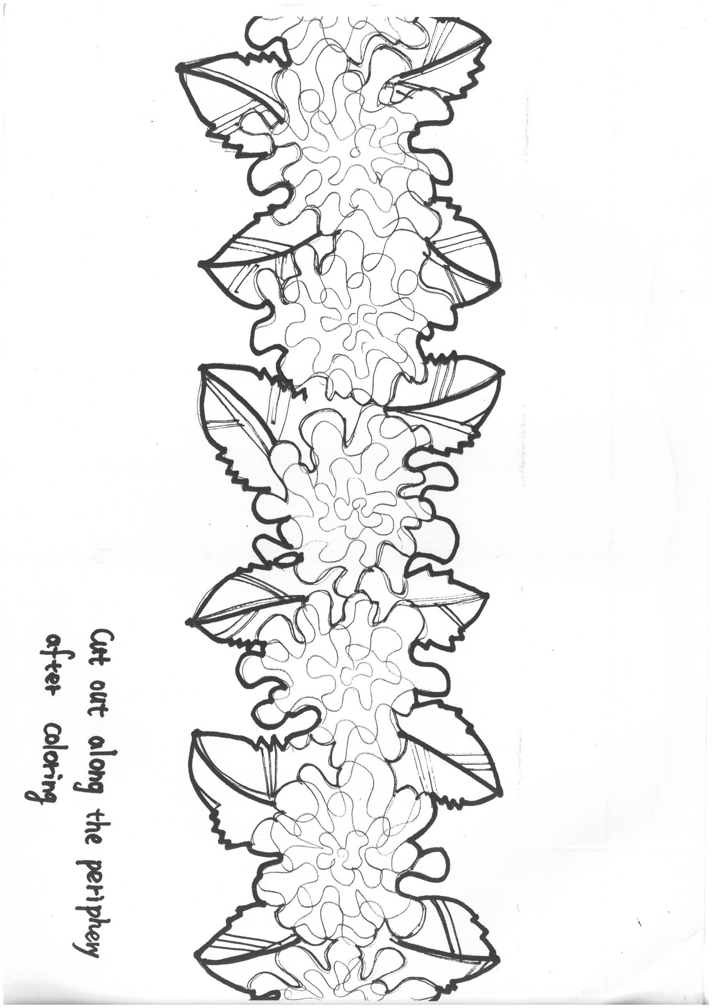

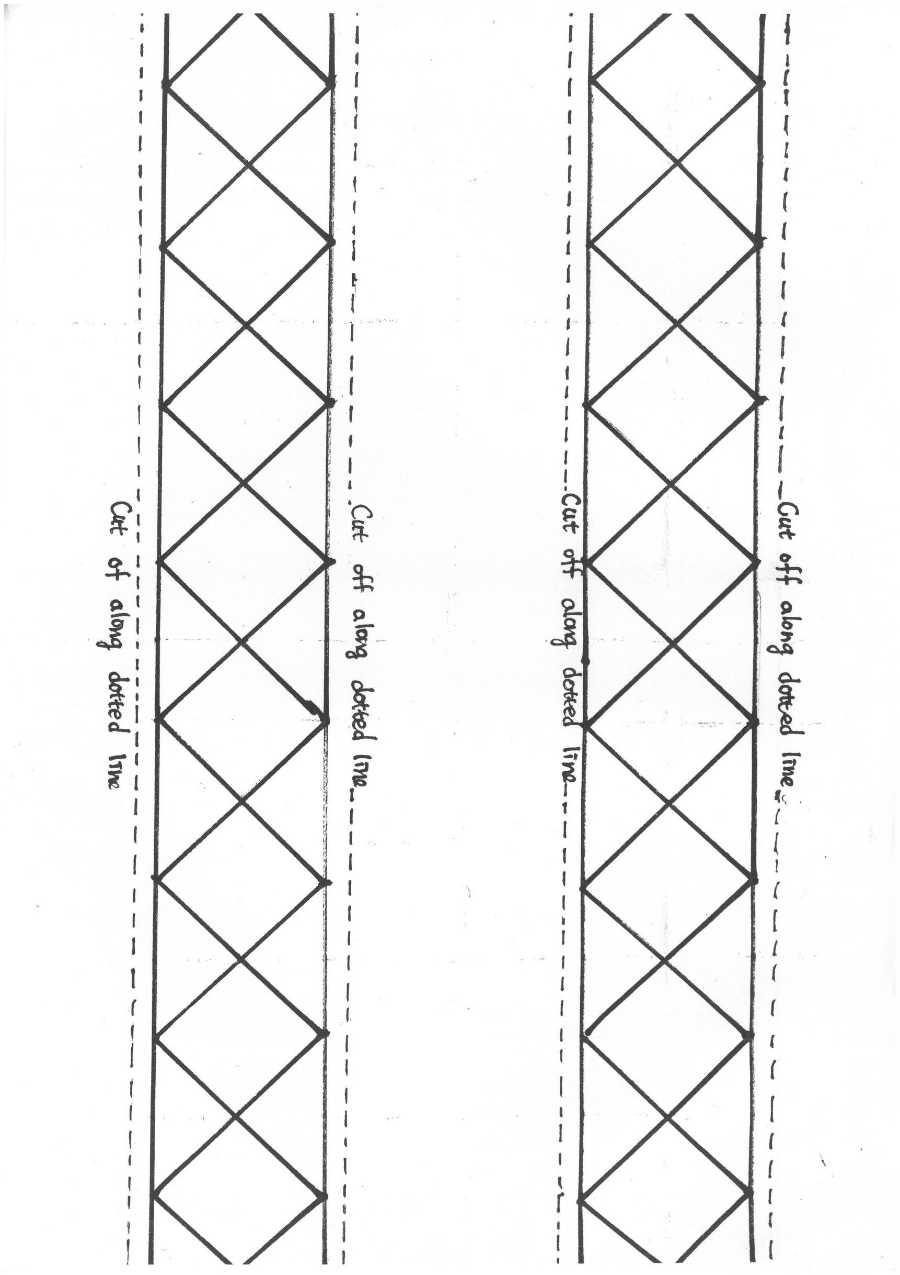

**Appendix 2. Creative Games**

1. Ice Breaker:

The following two actions represent two kinds of common fruits in Taiwan, namely pineapples and bananas.

* Lead the students to practice the actions of pineapples and bananas before the game begins.
* Choose a leader.
* When the game starts, all stand up and say the magic term “pa-pa-ya, pa-pa-ya, pa-pa-ya woo~boom”. Then each participant poses one of the actions at will.
* Those who pose the same action as the leader does are out and should sit down. Those who pose the other action then continue the game.  
  The leader may stop the game at any time. Those who are still standing when the game is over are the winners and will be given a prize.

1. Move forward with solidarity and unity

Just as the various ethnic groups have lived together in Taiwan for more than 400 years, we should remain in solidarity and never give up despite all the difficulties and adverse situations.

The rule for the game (about 5-10 minutes)

Step 1. Divide the participants into small groups of three or more. All the members of each group stand back-to-back and are bound together with a roll of toilet paper (or some kind of strips that can be broken easily).

Step 2. All the groups move toward the post from the starting line. After reaching the post, go around it and come back to the starting point. If the toilet paper is broken on the way, the group has to be bound together again by the teacher on the spot and then move on. The group that finishes the game first is the winner.

1. Taiwan GO GO GO

The aim of this game is to learn about the characteristics of Taiwan.

* There are 3 different themes for this game: special products, unique species, and indigenous tribes. The leader may choose one of them to play the game, based on the students’ age.
* This game is a variation of the classical hand game “Rock, Paper, Scissors”. It is usually played between two people, in which each player simultaneously forms one of three shapes with an outstretched hand. These shapes are rock (a closed fist), paper (a flat hand), and scissors (a fist with the index finger and middle finger extended, forming a V). Rock crushes scissors, scissors cut paper, paper cover rocks. And then each participant first needs to look for someone who poses the same action as he/she does as his/her partner in playing the game “Rock, Paper, Scissors”.
* Before the game starts, make sure to practice all the actions for the chosen theme until the students can remember them all.
* Begin the game by posing the action marked START. The winner of each round poses the next action and looks for someone posing the same action to play the game with. The loser of each round must pose the action marked START and start the game over. The game is finished when someone reaches the last action marked WINNER.

*Theme 1: Special products*

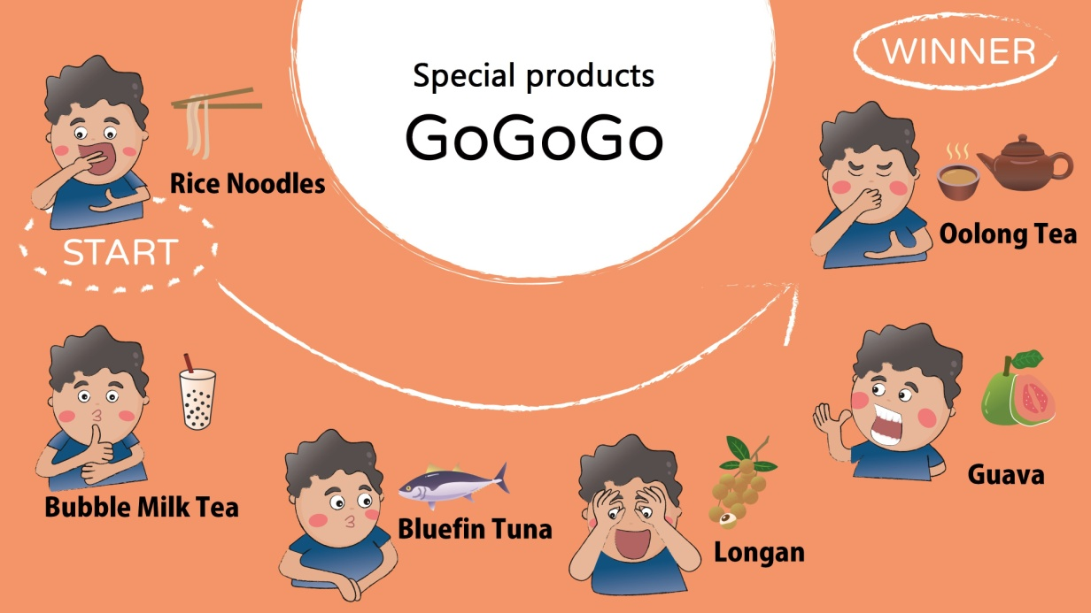

Different Pose (from left to right)

1. Rice Noodles
2. Bubble Milk Tea
3. Bluefin tuna
4. Longan
5. Guava
6. Oolong Tea

*Theme 2: Unique Taiwanese species*

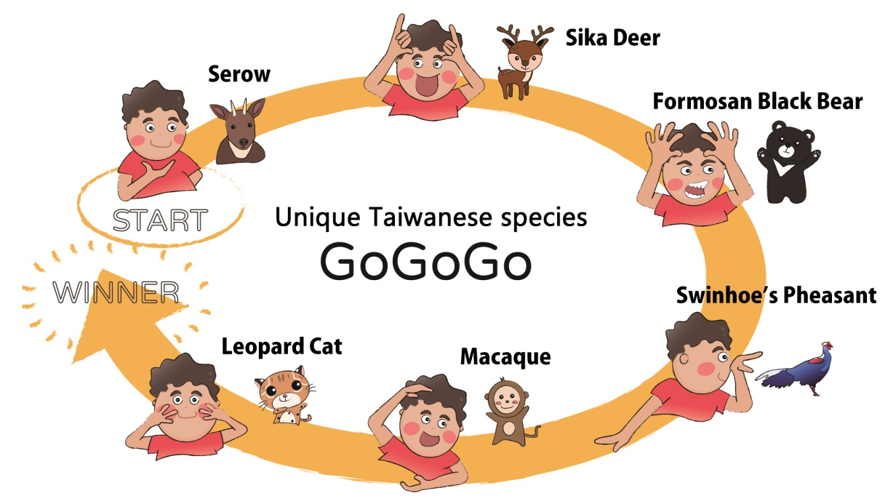

Different Pose (from left to right)

1. Serow 4. Swinhoe’s Pheasant
2. Sika Deer 5. Macaque
3. Formosan Black Bear 6. Leopard Cat

*Theme 3: Indigenous tribes in Taiwan*

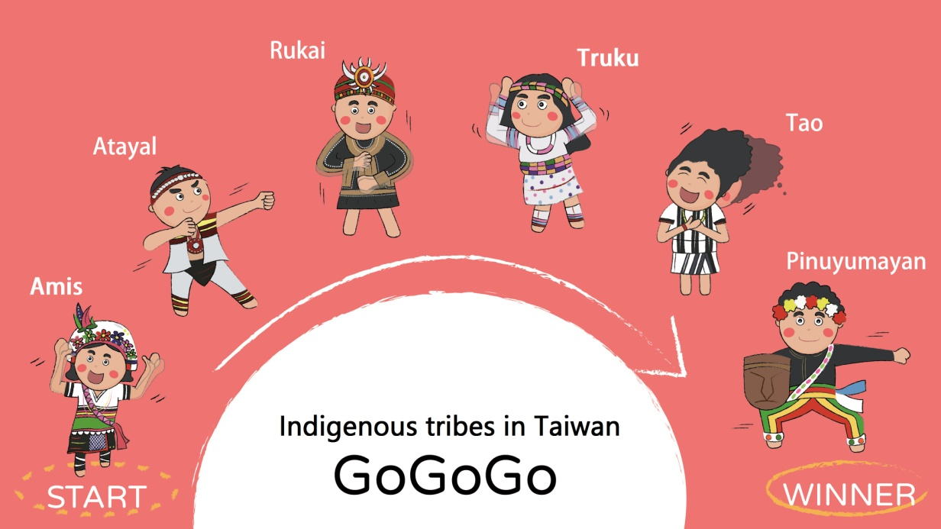

Different Pose (from left to right)

1. Amis 4. Truku
2. Atayal 5. Tao
3. Rukai 6. Pinuyumayan