World Day of Prayer
Prepared by the WDP Committee of Taiwan
March 3, 2023
“I Have Heard About Your Faith
Worship Service
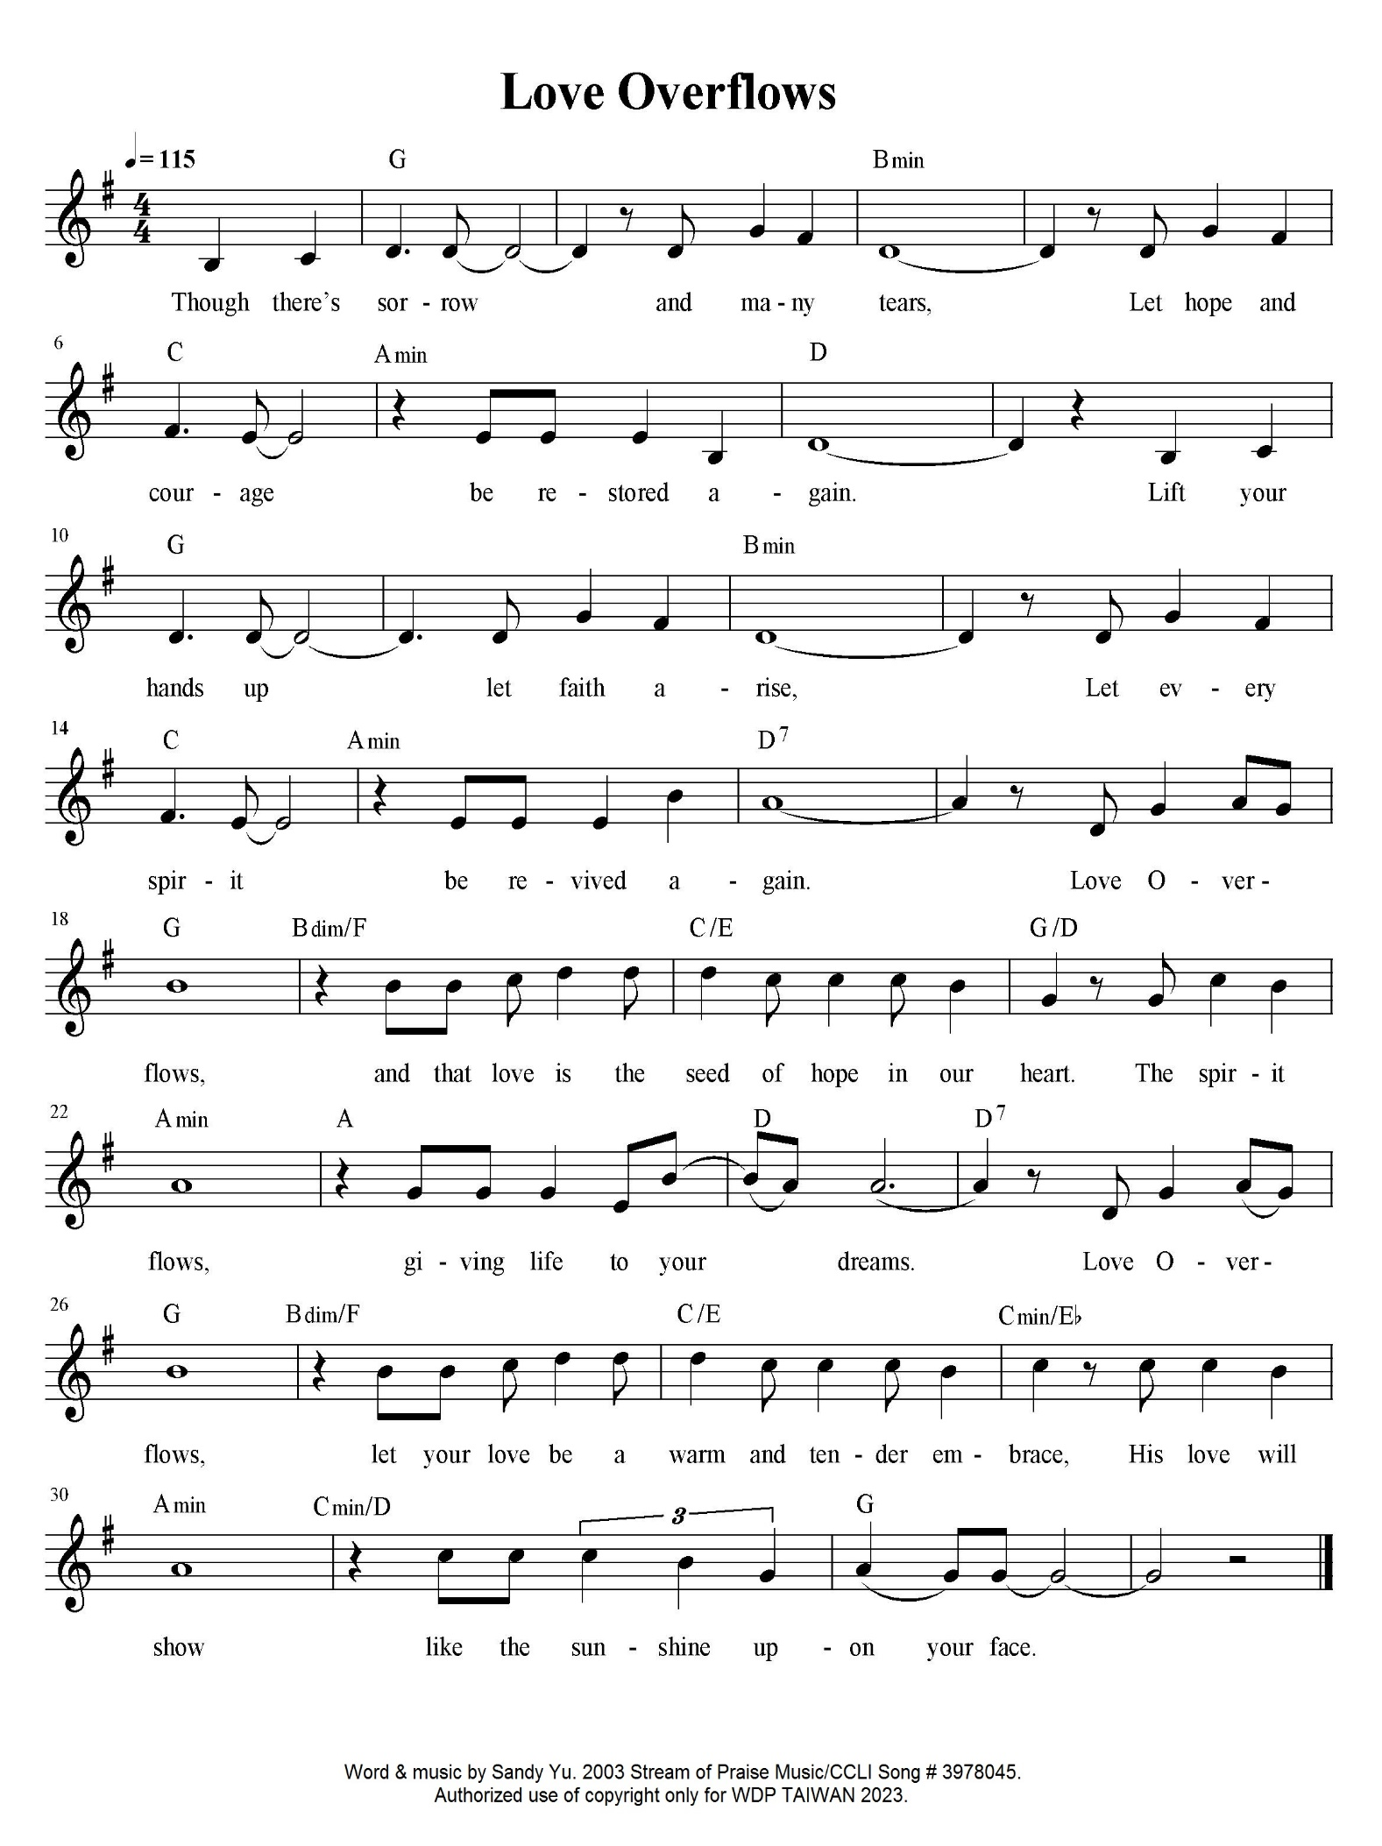
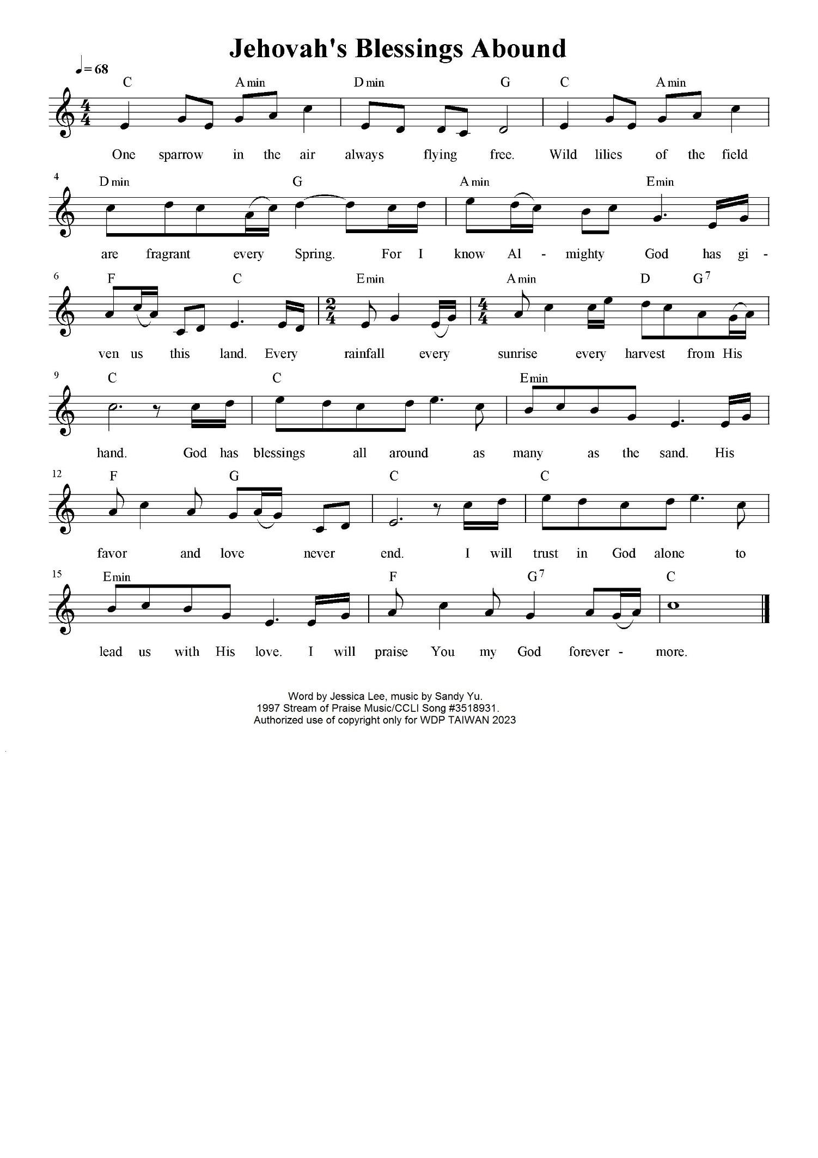
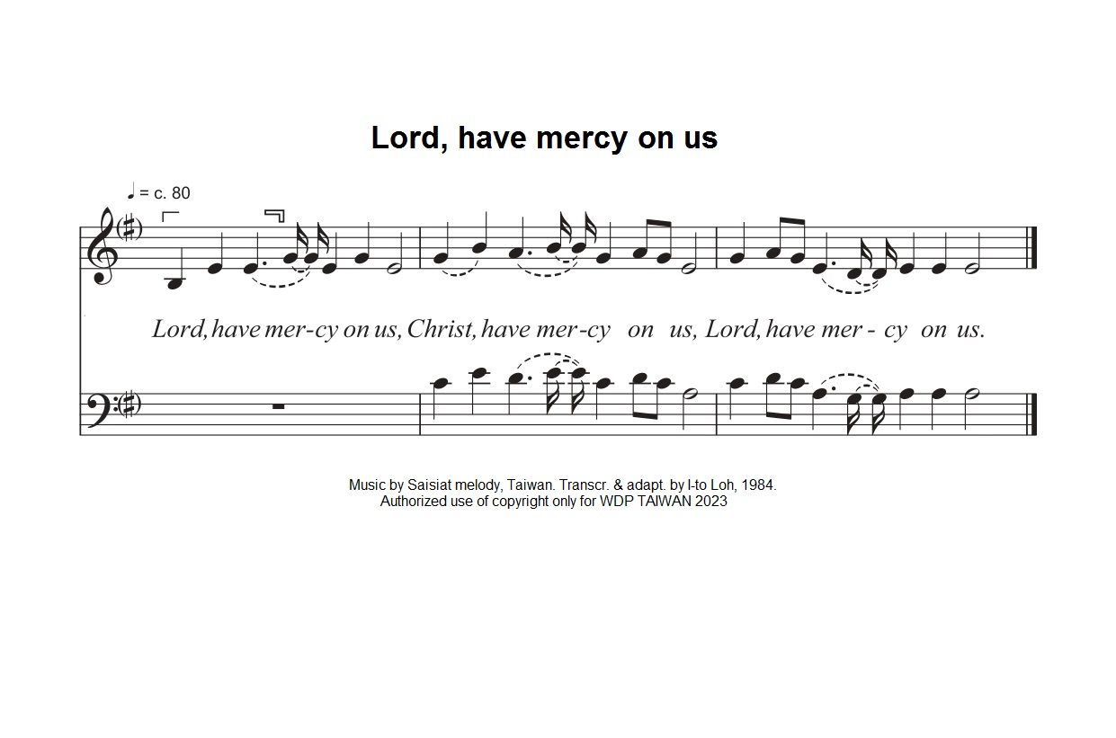
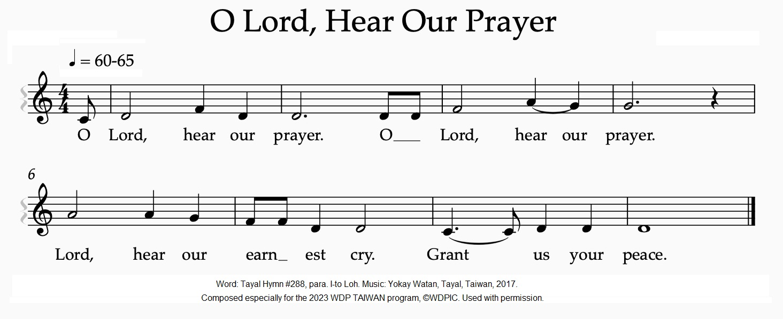
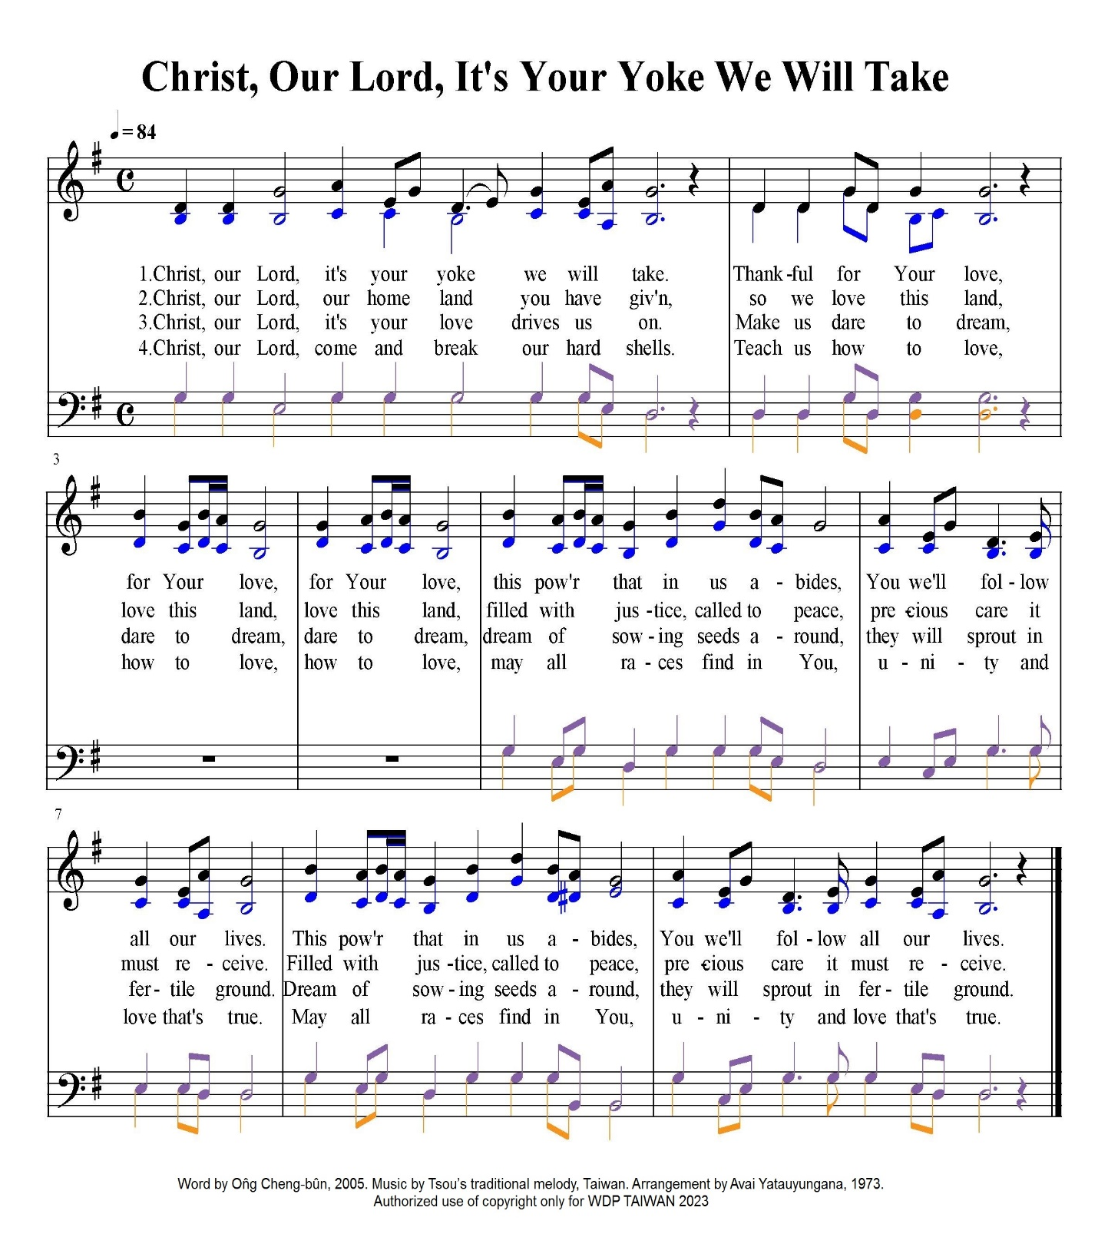

Copyright © 2021 World Day of Prayer International Committee, Inc.

“I Have Heard About Your Faith” was prepared by the World Day of Prayer Committee of Taiwan for the worship service and educational activities for the 2023 World Day of Prayer (WDP) annual celebration. WDP materials are developed for the exclusive use of WDP programs organized by national or local committees and their partner organizations. For any other use, materials from the WDP 2023 Resource Packet may not be reproduced without the permission of World Day of Prayer International Committee (WDPIC).
Limited reproduction rights granted—Bible study, Worship Service, Country Background, Children’s Program, Artwork and Artist Statement, WDP composed songs and photos may be reproduced—printed or electronically—for WDP activities with congregations and groups, if appropriate credit is given. WDP National/Regional Committees are permitted to resell reproductions of the resources for the purposes of the WDP program.
The songs suggested for the worship service and children’s program include copyrighted information from the publishers. Permission to reproduce or translate the copyrighted songs was given only for the use of WDP Taiwan 2023.
Only WDP National/Regional Committees connected with WDPIC can make the resource packet or sections of the materials available online. Committees that make materials available online must ensure groups and individuals who access the online materials are accountable to the committee.
Any offerings or funds collected related to WDP activities must be reported to WDP committees.
Scripture quotations are from the New Revised Standard Version of the Bible, copyright © 1989 by the Division of Christian Education of the National Council of Churches of Christ in the U.S.A. and are used by permission. All rights reserved.

For further information, please, contact:
World Day of Prayer International Committee
475 Riverside Drive Room 729
New York, NY. 10115. USA
admin@worlddayofprayer.net - http://worlddayofprayer.net

